NIHR Manchester BRC - The Clinical Research Investment Scheme

BRC Background and Context
Manchester Biomedical Research Centre (Manchester BRC) has been awarded £60.4 million from 2022 to 2027. Our goal is to drive personalised care for all through early phase, translational research. Our research spans across 13 themes arranged into four clusters: (1) High burden Under-researched Conditions; (2) Cancer; (3) Inflammation; and (4) Disease Complexity and Multi-Morbidity.

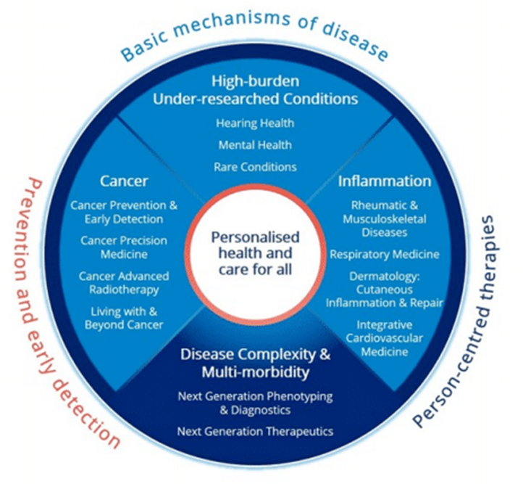
BRC Aims
The BRC aims to:
- Embed: Early translational research further into our communities and localities in GM, Lancashire and South Cumbria by deepening the meaningful involvement of patients, public and civic partners.
- Build: A unique national powerhouse for innovation by combining the world-leading discovery and translational science capabilities of our partnership with a strong research culture centred on a committed, diverse and inclusive workforce.
- Accelerate: At scale, the impact of our research through our mature and integrated innovation pipeline in order to achieve measurable improvements in health and wellbeing across all sections of society in our region and beyond.
Capacity Building and Background to Scheme
Our overall ambition of the Clinical Research Investment Scheme (CRIS) is to invest in and increase the capacity of healthcare professionals with research experience focussing on experimental medicine / early phase translational research across the BRC partnership and region. Often healthcare professionals can be drawn away from research for a number of reasons and often focus on clinical delivery without having the opportunity to return back to clinical research.
This scheme forms part of our ambition and will provide an opportunity to those who are not currently undertaking research, but do have some research experience and want to build on their existing skillset to pursue a sustainable career in early phase, experimental medicine.
We are offering an opportunity for a registered healthcare professional in a substantive post to have protected research time of up to 0.2FTE over 2 years with a small amount of project funding to conduct a piece of high quality research, or high quality early translational research training supported by leading biomedical researchers from across the BRC, whilst developing ‘on the job’ skills around early phase trials. We expect that this support will help you build your network, and provide a catalyst for you to continue in research once you complete the award.
This opportunity does need to be aligned with the ambition to continue in an experimental medicine / early phase translational research career. We are therefore aiming to kick-start you and your research on a sustainable basis for the longer-term (e.g., continuing or increasing PAs focussed on research after the award).
To apply for the scheme you will need to consider how this award will extend your research skills and experience, how partnering with the BRC will give you and your research added value, and how this award will support your longer-term ambitions within your host trust.
Duration and Time Commitment
This will up to 0.2FTE (2 Programmed Activities (PAs)) per year for two years starting no later than February 2025.
Eligibility
This scheme aims to bring registered healthcare professionals in substantive posts back into translational / experimental medicine research after a period of time of focussing on clinical delivery. In order to apply for this scheme you will need to
- Hold a substantive contract with an NIHR Manchester BRC partner Trust. This includes but is not limited to: nurses, midwives, allied health professionals, doctors, pharmacists, and clinical scientists.
- Be working at consultant level or in other senior roles, for example Agenda for Change band 7 or above
- hold a PhD, MD or equivalent, for example three years’ consolidated research time where you have been the intellectual drive behind a project and achieved strong outputs from your research experience
- not be undertaking any substantive research activity and will usually have limited or no research funding. We expect you will currently have less than half a day per week dedicated to research within your current contract. For example, less than one Programmed Activity, a week within your current job plan.
- be working at a senior level with specialised knowledge and have demonstrated some capacity for professional independence/leadership
- have the support of your NHS organisation or equivalent who can guarantee your research time will be protected during this grant
- Have a clear plan and written support from your employing Trust for continuing the protected research time BEYOND the tenure of this grant (see below).
There are no eligibility rules based on age or time since you obtained your PhD or MD. However, if you don’t have a significant break in research activity you will need to articulate the added value of this award.
Support from your host institution and BRC
The BRC will fund the following:
- Up to 20% contribution to your salary to support protected research time;
- research consumables, including small items of equipment costing less than £5,000 including VAT.

The BRC will provide the following at no-cost:
- Comprehensive training and mentorship to run clinical trials or other translational/EM studies in collaboration with the NIHR Manchester Clinical Research Facility (CRF);
- Core infrastructure expertise (including Patient and Public Inclusion and Engagement, Inclusive Research, Equality, Diversity and Inclusivity, Digital and Methodological advice) and training opportunities.

Project Proposal Areas
We are looking for experimental medicine / early phase translational research projects and training programmes that are focussed on your area of interest and expertise, and align with BRC Strategic Objectives and themes of work such that the collaboration is mutually beneficial. This award looks to develop skills around early phase trials, and provide you with on-the-job training. The awards will be flexible based on your needs. In particular, we would welcome research aligned with on-going early phase trials and projects across the Manchester BRC/Manchester CRF, which will then be able to support you with your research.

Assessment Criteria
Applicants to this scheme will be expected to demonstrate a keen interest in early phase, experimental medicine aligned with the BRC, and a clearly articulated plan for how the award will support future research, including skills and experience that you hope to gain through undertaking the award.
The panel will assess the award based on the following criteria:
- The applicant is committed to integrating future skills into their work and research;
- The quality of the research and training proposed and alignment with BRC themes and strategic objectives;
- The provision of an environment for you to develop research and skills;
- Appropriateness of the proposed academic support and mentorship;
- A clear commitment from the host Trust to continue supporting you to deliver translational / EM studies and trials beyond this funding period (e.g., letter).

Application Process
We will operate a two stage application process for this scheme. The first will be an expression of interest through completion of the Expression of Interest form.
This will be reviewed by a core academic team. Following this you will then asked to write your research plan in more detail including any ethics required. You will be provided with this form once shortlisted.
Proposed Timeframes
Application Milestones | Date/Time
Expression of Interest Opens | w/b 4th December 2023
Information Session | 13th December 1pm-2pm
Expression of Interest Submission Deadline | 5th February 2024
Review panel to Triage applications | w/b 19th February 2024
Discussion with Trusts re. positions | w/b 4th March 2024
Full application process opens | 1st April 2024
Full application process closes | 21st June 2024
Review Panel | w/b 8th July 2024
Scheme starts | No later than January 2025

Manchester BRC Clinical Research Investment Scheme
Expression of Interest Form
(to be submitted to Professor Georgina Moulton (georgina.moulton@manchester.ac.uk)
Applicant Details
Name
Title
Job Role and Position
Host Organisation
Host Department/Speciality
Professional Registration Number
Current NHS Grade
Email
Date of completion for PhD/MD
Current Job Plan /Working Arrangements
Area of Research / BRC Theme Alignment

Team members (including mentors, supervisors and professional staff)
Name (s)
Title
Current Position
Host Organisation
Host Department
Email
Role on project

Project Details
Project Title
Project Start Date
Research Project and/or Training Programme Vision (in this section outline the importance of the field/areas, how it advances current understanding of the area; it’s importance and alignment with current work; and its potential impact)
Project (Training Programme) Outline (up to 1000 words, and to include a set of objectives and how they are to be achieved, proposed methodology, how it builds on other work, and the risks to delivery. Please include a separate gantt chart)
Added Value of Award to you (up to 700 words and to include the skills / experience to be developed throughout award; how it will support you in the future; and next steps)
BRC Research Supporting Statements showing how the environment will support you, the role of the team members in more detail - how their expertise fits with your proposal, and how they will support you through the two years, developing your skills and experience
Host Organisation Supporting Statement detailing the commitment and support from your host department and Trust. It should include the name and role of the person of a senior manager; support during the award as well as a clear plan to support your research time AFTER this award
Required Facilities (outline the facilities you will need to complete your research and support from the BRC)
Ethics Approval and Consideration (please detail any ethical implications with your research and whether ethics approval will need to be granted)

Project Finances and Justification
Total Cost Requested | £
Breakdown of Costs | Description | Cost
Applicant (and staff) |  | £
Consumables |  | £
Facilities and BRC Infrastructure required (e.g., PPIE, data analytics) |  | £

BRC partnership includes: Manchester University NHS Foundation Trust, The University of Manchester, Blackpool Teaching Hospitals NHS Foundation Trust, The Christie NHS Foundation Trust, Greater Manchester Mental Health NHS Foundation Trust, Lancashire Teaching Hospitals NHS Foundation Trust, and the Northern Care Alliance NHS Foundation Trust.

